------------------------------------------------------------------------------------------------------------------------------------------

_____________________________________________________________________________________

*Assignment # 1*

**ASSIGNMENT TOPIC:**

* Network Topologies.

Department: **Computer Science**

Course Title:

**Fundamental of ICT**

Course Code: **CS-100**

**Date of Submission: 28/March/2022**

1st Semester,

Session **2021-2025**

Submitted to: **Dr. Sir Abdullah Khan**

Submitted by: **Muhammad (391855)**

_____________________________________________________________________________________

**INTRODUCTION:**

A **network** is a way to connect computers together so that they can communicate, exchange information and share their resources amongst each other. In business or education, scientific or technological research, educational institutes or office atmosphere, network have revolutionized the use of computer technology. Be it a local area or wide area network, the world community has come closer to each other. The ocean of information is virtually on our table, using the smart powers of browsing and surfing the resources of world’s largest network. For instance, **Internet**.

­**NETWORK TOPOLOGIES:**

In networking the term topology refers to the layout of connected devices on a network. One can think of a topology as a network’s “**shape**”.

Network topology are categorized into the following basic types given below:

**Bus, Ring, Star, Tree and Mesh.**

More complex networking can be built as hybrids of two or more of the above basic topologies.

1. **BUS:**

These networks use a common backbone to connect all devices. A single cable, the backbone functions as a shared communication medium, such that devices attach or tap into with an interface connector. A device wanting to communicate with another device on the network broadcast a message onto the wire that all other devices see, but only the intended recipient actually accepts and processes the message.

**Advantages of Bus Topology**:

* Easy to connect a computer or peripheral to a linear bus.
* Requires less cable length than a star topology.

**Disadvantages of Bus Topology:**

* Entire network shuts down if there is a break in the main cable.
* Terminators are required at both ends of the backbone cable.

**SHAPE:**

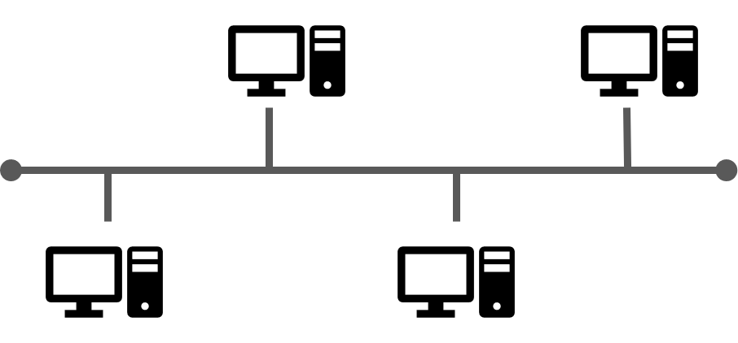

1. **RING:**

In a ring network, every device has exactly two neighbors for communication purposes. All messages travel through a ring in the same direction (effectively either “**clockwise**” or “**counterclock**”). A failure in any cable or device breaks the loop and can take down the entire network. Token passing scheme is used in this topology.

**Advantages of ring topology:**

* There is no need for a server computer to make the network.
* All computers behave the same and have the same processing power.

**Disadvantages of ring topology:**

* It is difficult to add or remove the node in ring topology because it will stop working on the network.

**SHAPE:**



1. **STAR:**

Many home networks use the star topology. A star network features a central connection point called a “**hub**” that may be an actual hub or a **switch**. Devices typically connect to the hub with **Unshielded Twisted Pair** (UTP) Ethernet. Compared to the bus topology, a star network cable will only take down one computer’s network access and not the entire LAN. If the hub fails, however, the entire network also fails.

Several star topology **advantages** and **disadvantages** are worth considering when you’re in the middle of a setup process. These are the critical points to review before starting the installation work. Star topology features a better fault tolerance. When a star topology experiences a cut cable or a NIC failure, then it will only affect one node.

**SHAPE:**

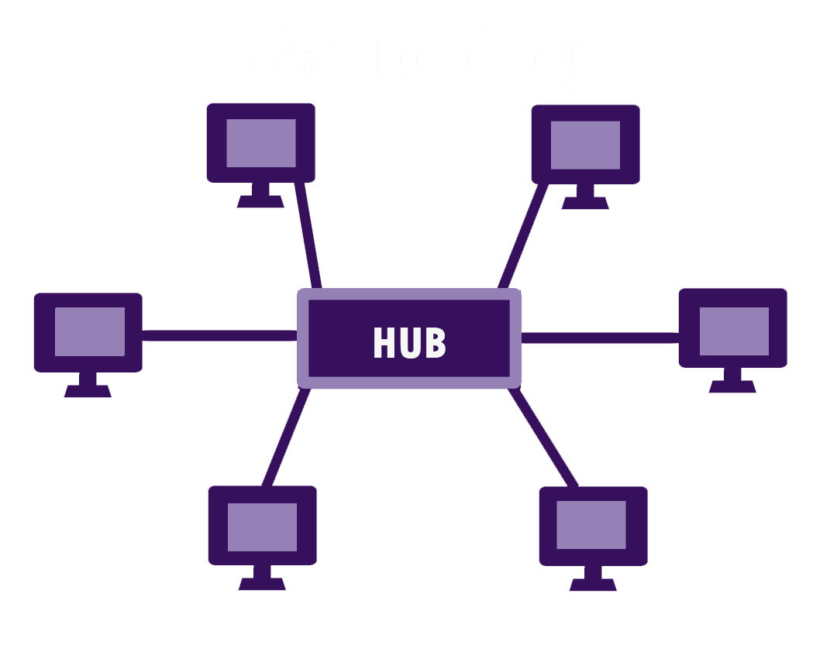

1. **TREE:**

Tree topologies combine **multiple** star topologies together onto a bus. In its simplest form, only hub devices connects directly to the tree bus, and each hub functions as the “**root**” of a tree of devices. This bus or star hybrid approach supports future expandability of the network much better than a bus (limited in the number of devices due to the broadcast traffic it generates) or a star (limited by the number of hub ports) alone.

**Advantage**:

* Well suited for large computer networks because the entire network is divided into parts and is, therefore, easier to manage.

**Disadvantage**:

* The entire network is dependent on central elements and a failure of these elements can paralyze the entire network.

**SHAPE:**

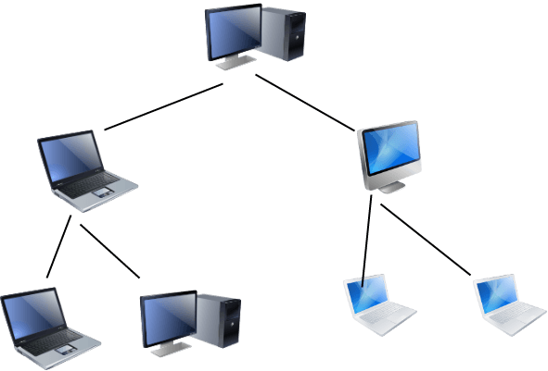

1. **MESH:**

Mesh topologies invole the concept of routes. Unlike each of the previous topologies, messages sent in a mesh network can take any of several possible paths from source to destination. (Recall that in a ring, althought two cable paths exist, messages can only travel in one direction.) Some WANs, like the Internet, employ mesh routing. A mesh offers several advantages over other network topologies.

**Advantages:**

* Mesh network has high fault tolerance due to multiple links.
* Due to multiple links mesh network can work fine even under severe loads.
* Troubleshooting of mesh network is easy as compared to other networks. If data is not communicated between any two computer then it means that there is some fault in direct links between them.

**Disadvantages** include the difficulty of installation and reconfiguration, as well as the cost of maintaining redundant links.

**SHAPE:**

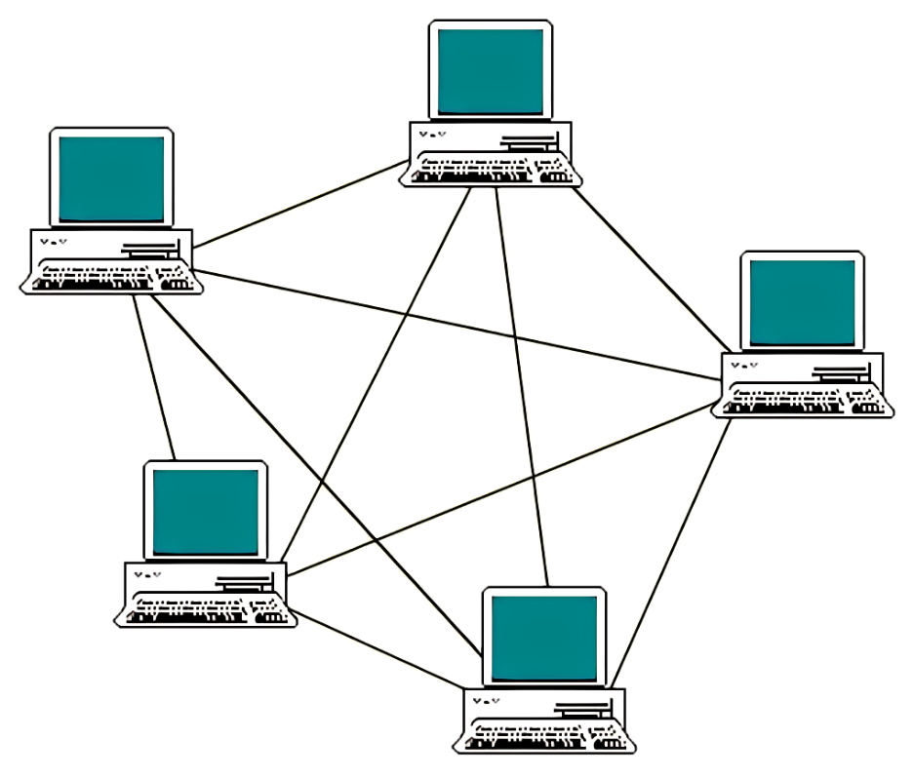

**THE END**